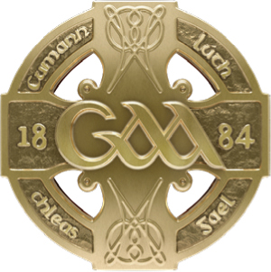
GAA GAA
Páirc an Chrócaigh Croke Park
Baile Átha Cliath 3 Dublin 3
Guthán +353 1 8658600 Telephone +353 1 8658600
Faics +353 1 8366420 Fax +353 1 8366420
www.gaa.ie www.gaa.ie

16ú Aibreán 2021

Do: Gach Rúnaí Chontae
Gach Runaí Chlub

Covid Update
A chara,

INFORMATION FOR CLUBS
Return to Training As you are aware non-contact training for underage teams in pods of 15 will be permitted from April 26th next in the 26 Counties. Our clubs in the North have returned in pods of 15 this week. “Underage teams” means any registered team at U-18 level or below.
Attached, please find the updated Guidelines for a Safe Return to Gaelic Games.
The key control measures remain completion of the online education module (which you can access here) and completion of the Health Questionnaire before each session (link to Health Questionnaire is here)

It is also important to remember that all indoor facilities must remain closed at this time, both North and South of the border.

Attendance at Training In general, only players and coaches of the relevant team should attend any training session. One Parent or Guardian per child (or per family if more than one child is attending from a particular family) is permitted to attend in a safeguarding /supervisory capacity involving any team in the U-18 or below age group, should they consider it necessary. However strict social distancing and public health guidelines should be adhered to at all times. In particular, it is important that parents do not congregate in groups before or after sessions, outside of what is permitted in current Government regulations.

Any person wishing to attend our underage training or games including coaches, parents, players and spectators shall be subject to the provisions of the Code of Behaviour (Underage).

Is muide, le meas,
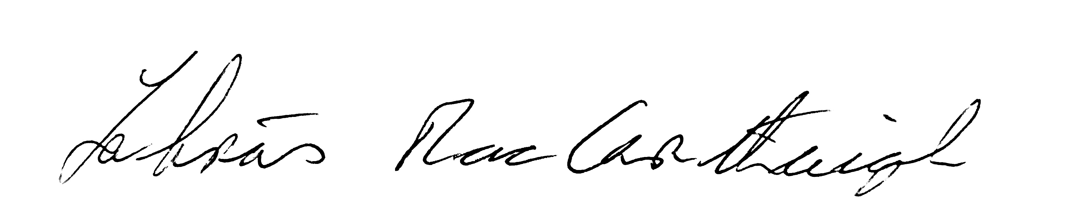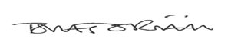

Labhrás Mac Carthaigh Tomás Ó Riain
Uachtarán Ard Stiúrthóir

